1. 
2. 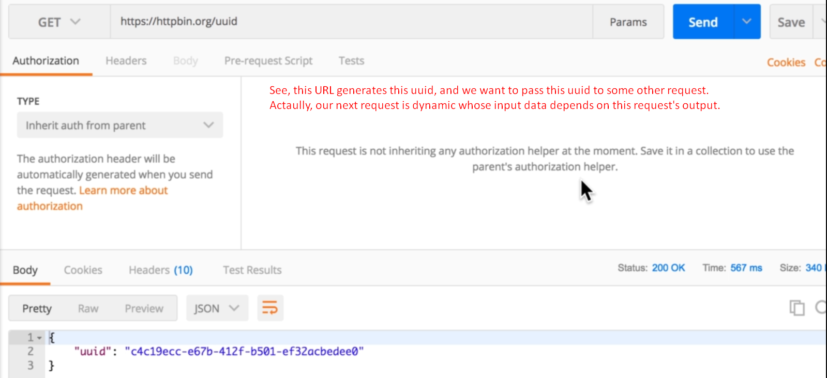
3. 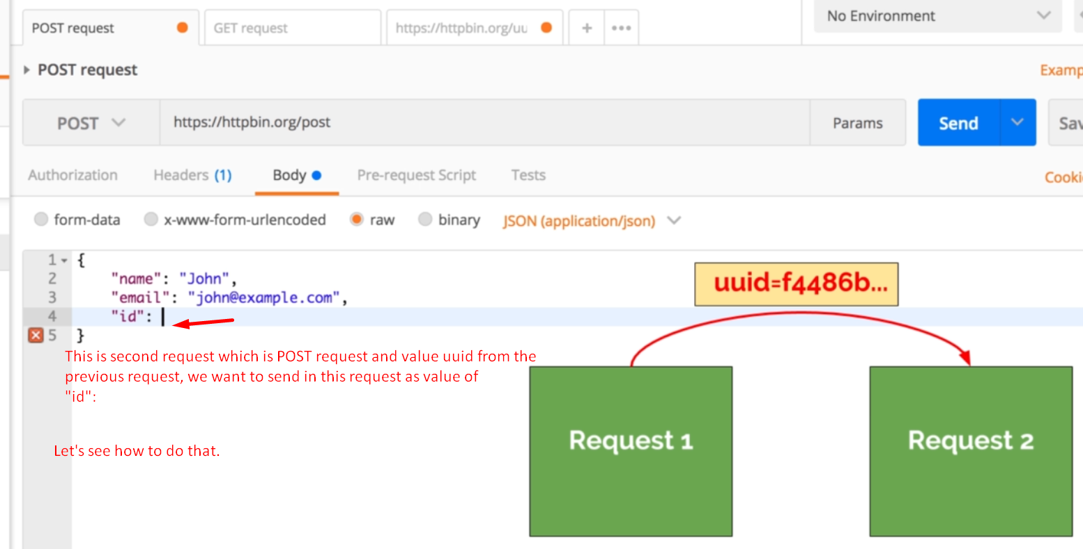
4. We can use the important feature of Postman that is “variable”.   
   And in order to work with variables, we need to dive a bit in a code.
5. Just click on the tab “test” which allows us
   1. To write tests.
   2. To write general code.
6. 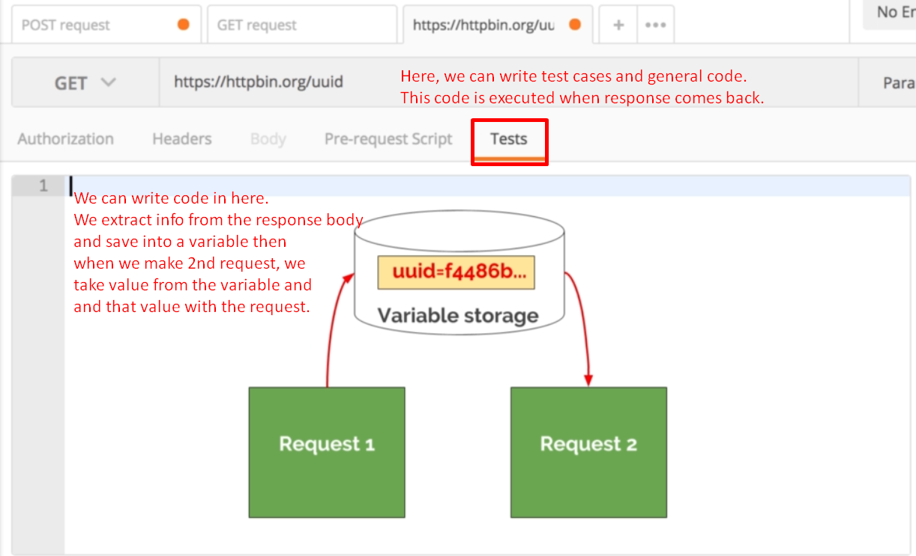
7. 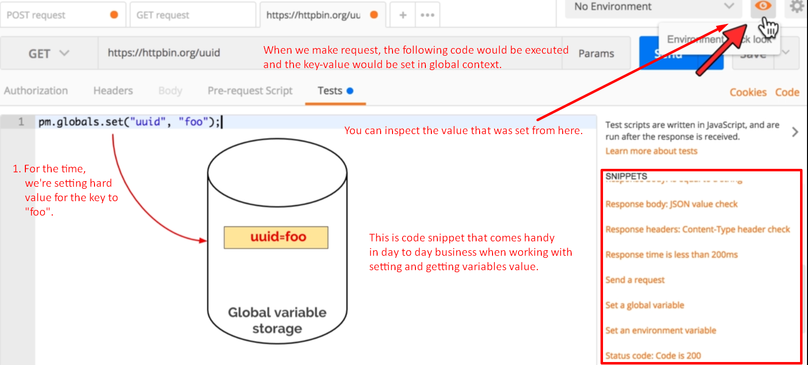
8. 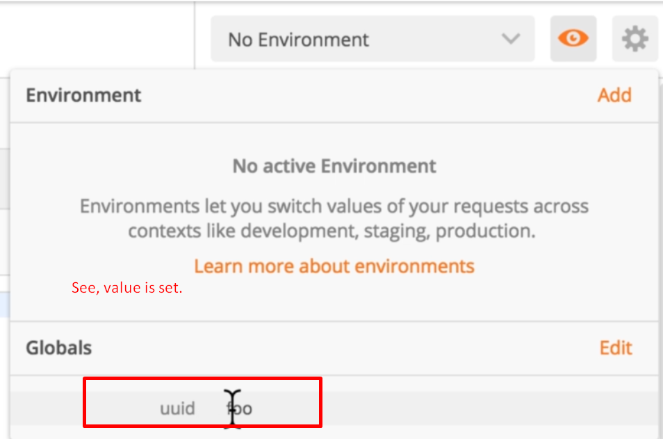
9. 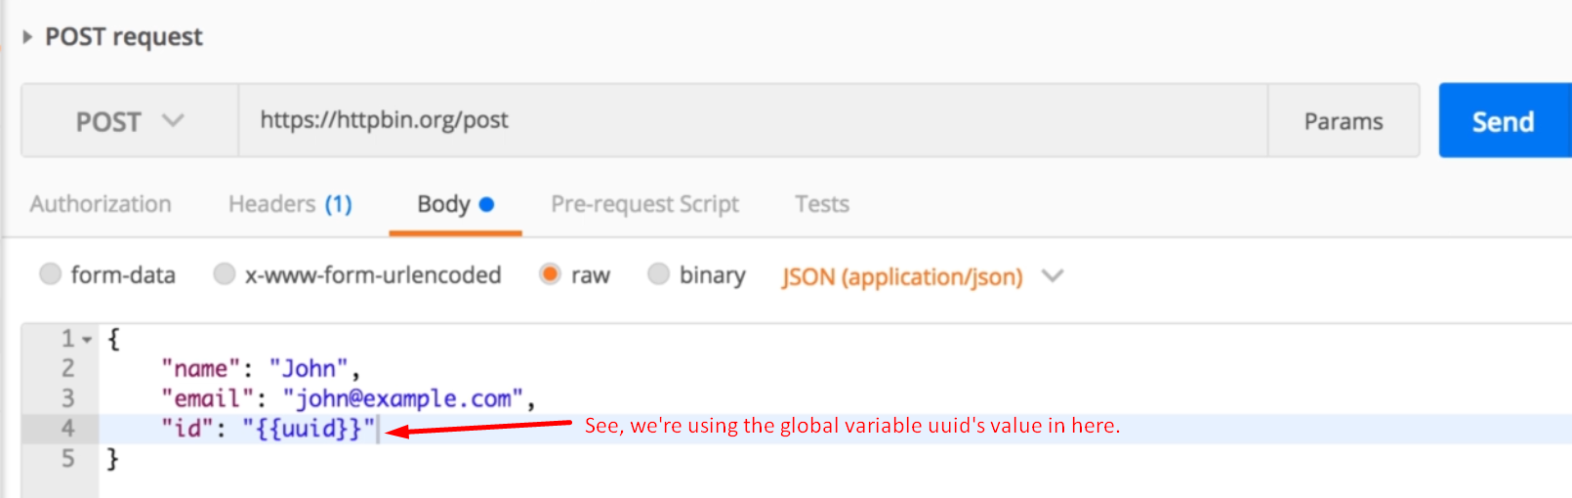
10. 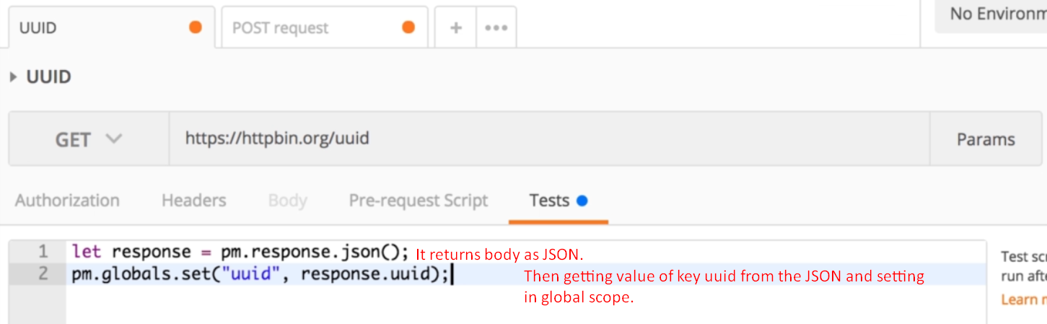
11. 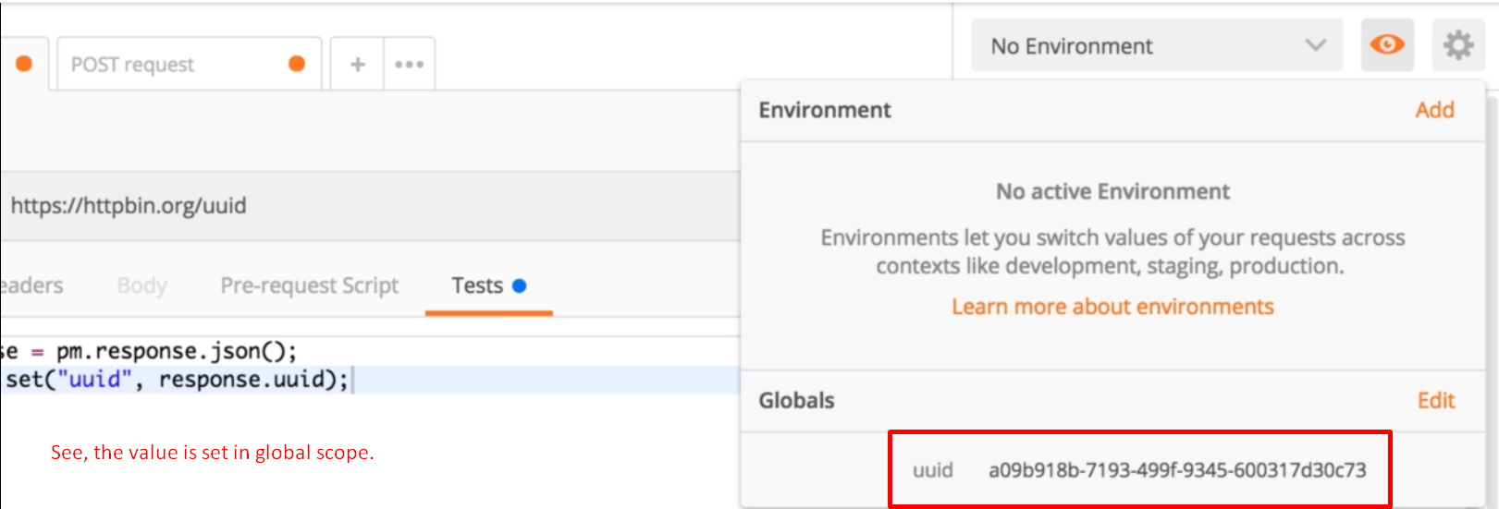
12. 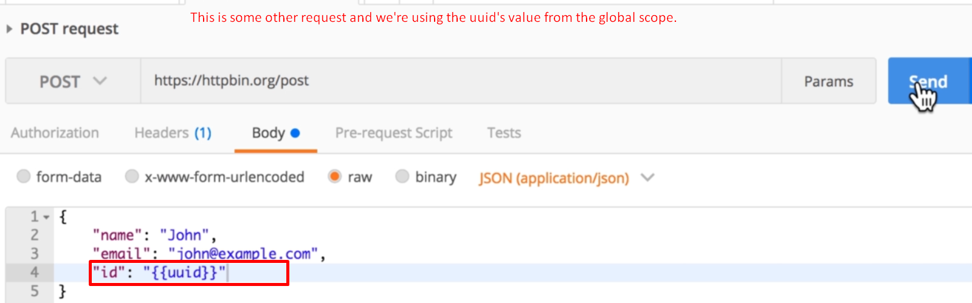
13. 
14. 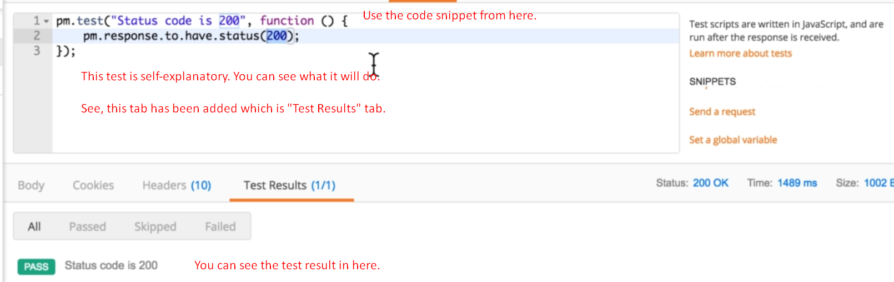
15. 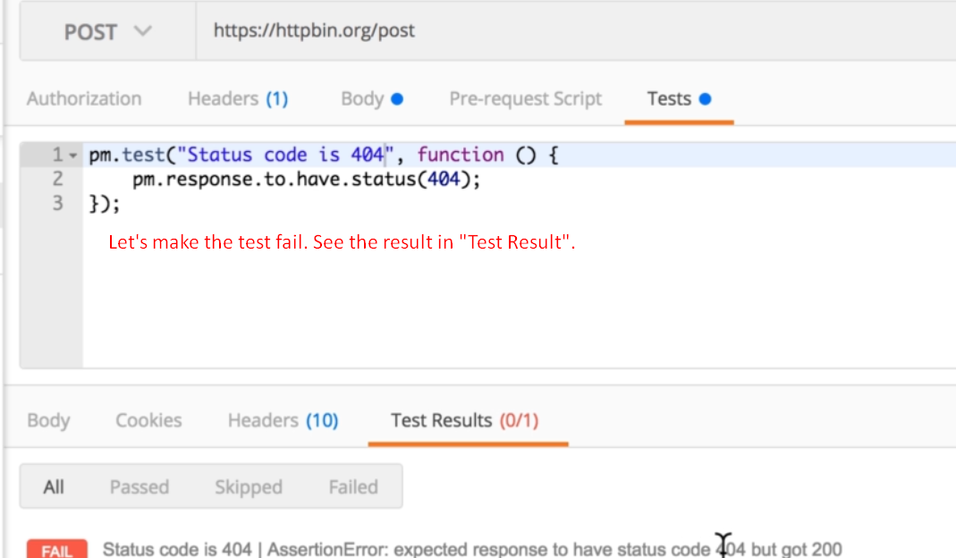
16. Let’s see how to run requests in sequence one after the other.
17. For that we use Postman runner.
18. 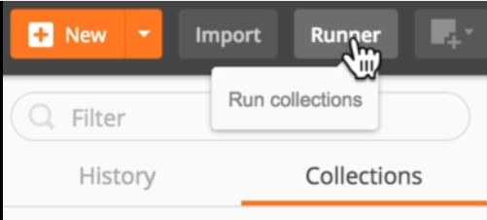
19. 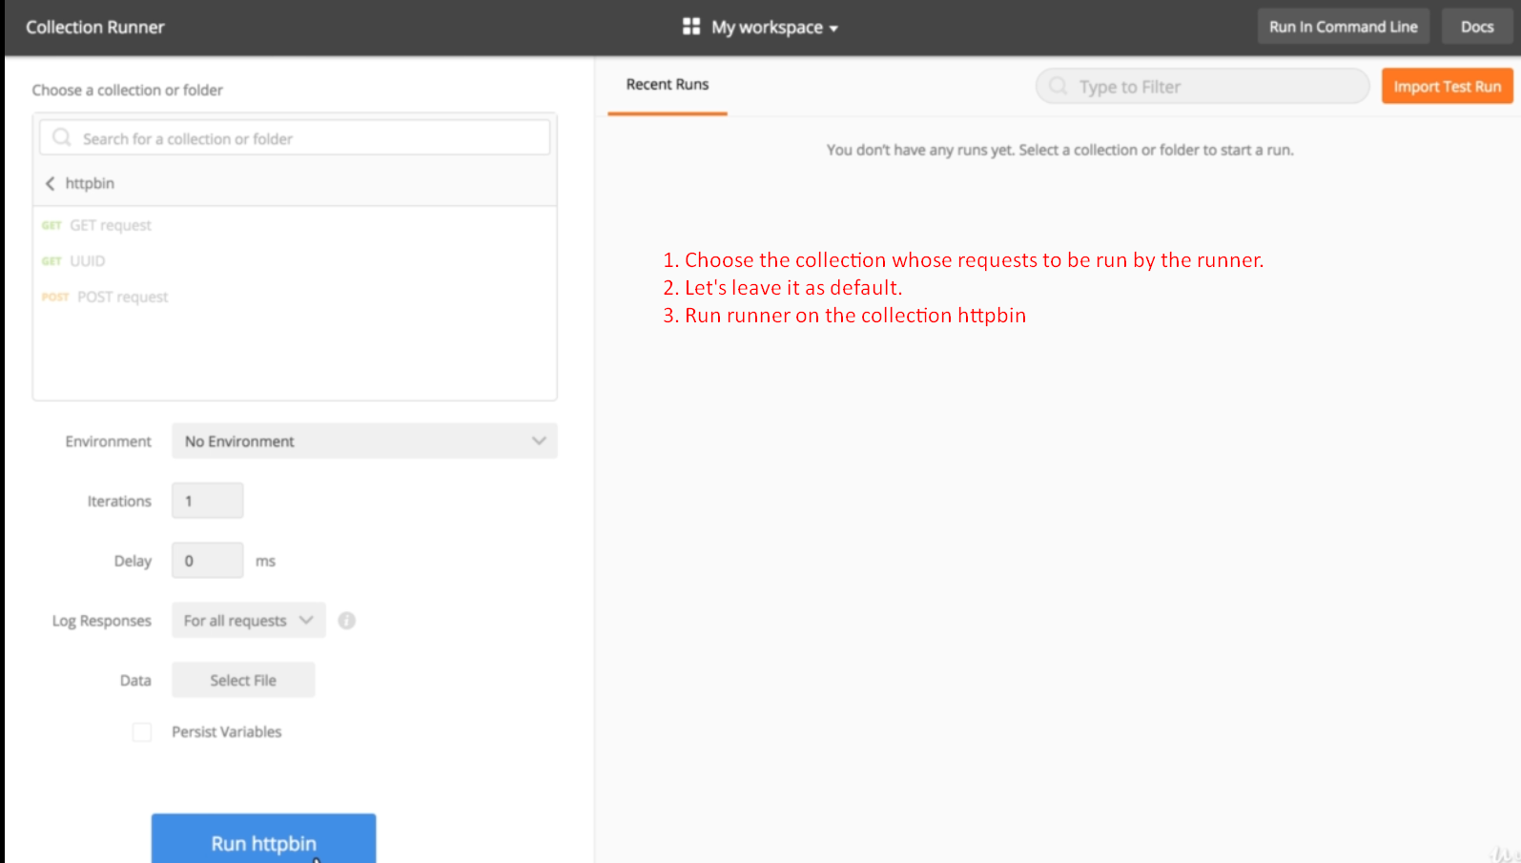
20. 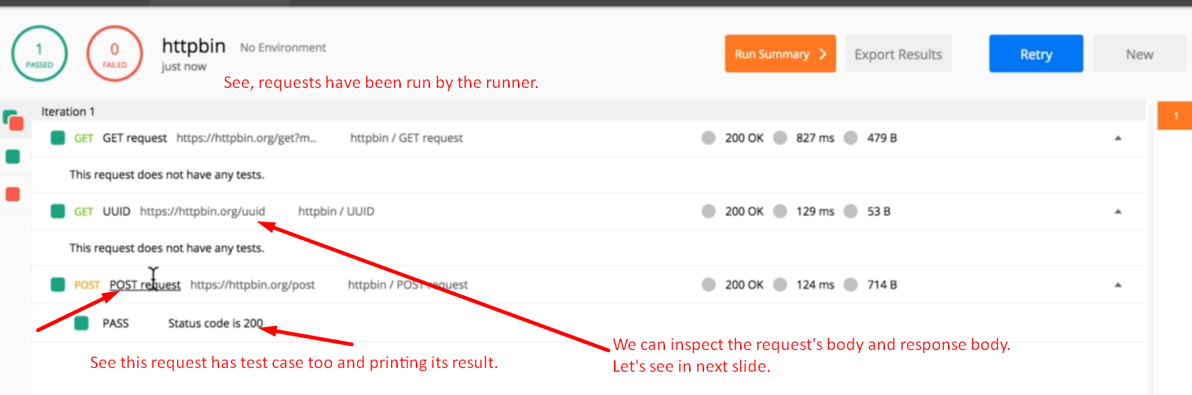
21. 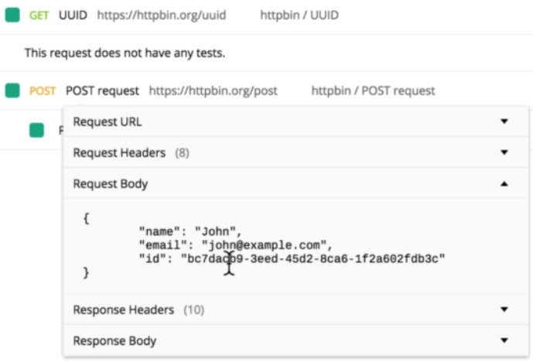
22. 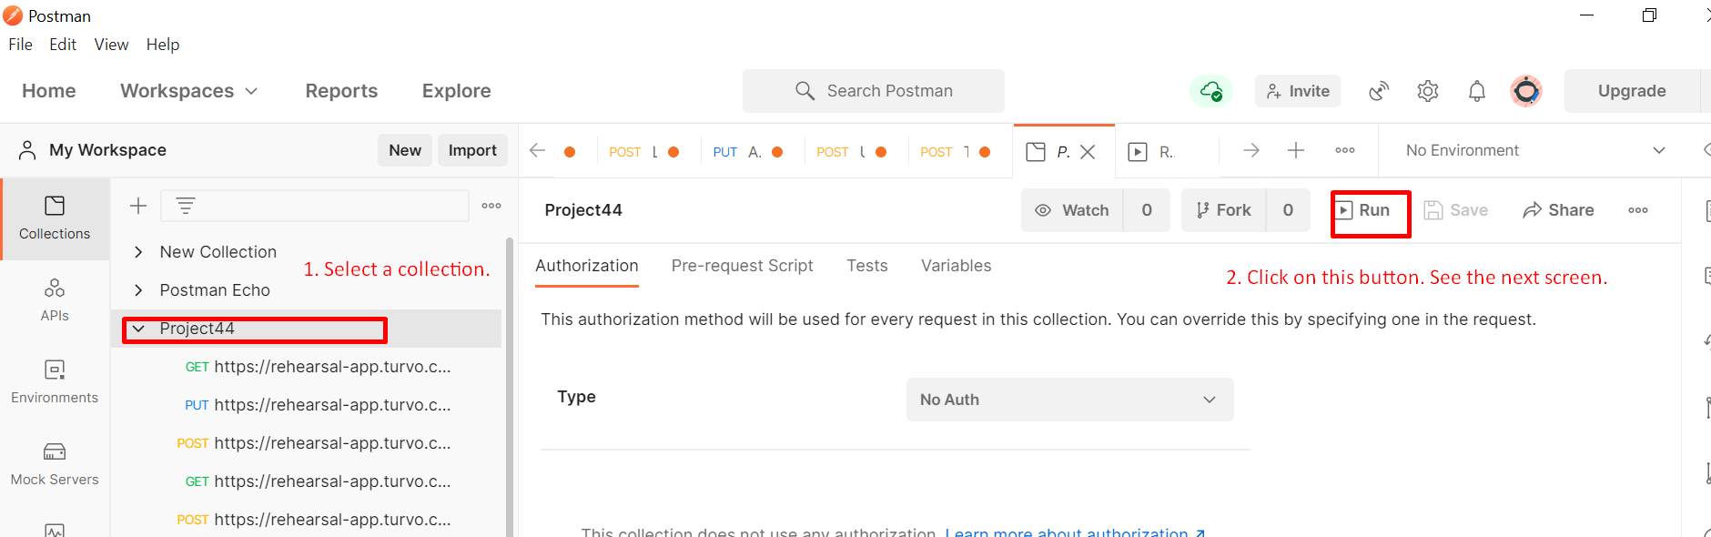
23. 